SIMULATION EXPERIMENT – 10 ❖ Full-Wave Simulation and Optimization of a Microstrip Patch Antenna for Resonant Frequency, Bandwidth, Gain and Radiation-Pattern Enhancement

Aim
To design and simulate a rectangular microstrip patch antenna for 2.4 GHz and optimize its patch length to obtain improved resonant frequency, impedance matching, bandwidth and radiation performance.

Objectives
- To design a rectangular microstrip patch antenna on an FR-4 substrate for a 2.4 GHz operating frequency.
- To investigate the effect of patch length on resonant frequency and impedance matching.
- To evaluate S₁₁, VSWR, return loss, bandwidth, gain, directivity, efficiency and radiation pattern.
- To compare patch lengths of 27.8 mm, 28.8 mm and 29.8 mm and select the optimized design.

MATLAB Program

Given parameters
Parameter | Value
Design frequency | 2.4 GHz
Substrate | FR-4
Relative permittivity | 4.4
Substrate thickness | 1.6 mm
Patch width | 37.2 mm
Initial patch length | 28.8 mm
Simulation range | 2.0–2.8 GHz
clc;
clear;
close all;

%% =====================================================
% SIMULATION EXPERIMENT - 10
% MICROSTRIP PATCH ANTENNA DESIGN AND OPTIMIZATION
%% =====================================================

c = 3e8; % Speed of light
f0 = 2.4e9; % Design frequency
er = 4.4; % FR-4 relative permittivity
h = 1.6e-3; % Substrate thickness
W = 37.2e-3; % Patch width
L0 = 28.8e-3; % Initial patch length

%% =====================================================
% 1. THEORETICAL PATCH DIMENSIONS
%% =====================================================

Wcalc = (c/(2*f0))*sqrt(2/(er+1));

eeff = (er+1)/2 + ...
((er-1)/2)*(1+12*h/W)^(-0.5);

deltaL = 0.412*h*((eeff+0.3)*(W/h+0.264))/ ...
((eeff-0.258)*(W/h+0.8));

Leff = c/(2*f0*sqrt(eeff));

Lcalc = Leff - 2*deltaL;

fprintf('============================================\n');
fprintf('MICROSTRIP PATCH ANTENNA DESIGN\n');
fprintf('============================================\n');

fprintf('\nSpecified Width = %.2f mm\n',W*1000);
fprintf('Calculated Width = %.2f mm\n',Wcalc*1000);

fprintf('Specified Length = %.2f mm\n',L0*1000);
fprintf('Calculated Length = %.2f mm\n',Lcalc*1000);

fprintf('Effective Dielectric Constant = %.4f\n',eeff);

fprintf('Fringing Length = %.4f mm\n',deltaL*1000);

%% =====================================================
% 2. FREQUENCY SWEEP
%% =====================================================

f = linspace(2.0e9,2.8e9,1001);

%% =====================================================
% 3. INITIAL PATCH RESONANT FREQUENCY
%% =====================================================

fr0 = c/(2*(L0+2*deltaL)*sqrt(eeff));

fprintf('\nInitial Resonant Frequency = %.4f GHz\n',...
fr0/1e9);

%% =====================================================
% 4. APPROXIMATE S11 MODEL
%% =====================================================

% Quality factor used for approximate antenna response
Q = 30;

% Frequency-dependent reactance
X = 50*(f/fr0 - fr0./f);

% Input impedance
Z = 50 + 1j*X;

% Reflection coefficient
Gamma = (Z-50)./(Z+50);

% S11
S11 = 20*log10(abs(Gamma));

% VSWR
VSWR = (1+abs(Gamma))./(1-abs(Gamma));

%% =====================================================
% 5. RETURN LOSS GRAPH
%% =====================================================

figure;

plot(f/1e9,S11,'LineWidth',2);

grid on;

xlabel('Frequency (GHz)');
ylabel('S_{11} (dB)');

title('Return Loss of 2.4 GHz Microstrip Patch Antenna');

hold on;

yline(-10,'--');

xline(2.4,'--');

legend('S_{11}','-10 dB','2.4 GHz');

%% =====================================================
% 6. FIND RESONANT FREQUENCY
%% =====================================================

[minS11,index] = min(S11);

fr = f(index);

fprintf('\nMinimum S11 = %.2f dB\n',minS11);

fprintf('Simulated Resonant Frequency = %.4f GHz\n',...
fr/1e9);

%% =====================================================
% 7. VSWR
%% =====================================================

figure;

plot(f/1e9,VSWR,'LineWidth',2);

grid on;

xlabel('Frequency (GHz)');
ylabel('VSWR');

title('VSWR versus Frequency');

hold on;

yline(2,'--');

legend('VSWR','VSWR = 2');

%% =====================================================
% 8. -10 dB BANDWIDTH
%% =====================================================

BWindex = find(S11 <= -10);

if ~isempty(BWindex)

fL = f(BWindex(1));
fH = f(BWindex(end));

BW = fH-fL;

fprintf('\n--- BANDWIDTH ---\n');

fprintf('Lower Frequency = %.4f GHz\n',...
fL/1e9);

fprintf('Upper Frequency = %.4f GHz\n',...
fH/1e9);

fprintf('Bandwidth = %.2f MHz\n',...
BW/1e6);

else

fprintf('\n-10 dB bandwidth not found.\n');

end

%% =====================================================
% 9. INPUT IMPEDANCE
%% =====================================================

figure;

plot(f/1e9,real(Z),'LineWidth',2);

hold on;

plot(f/1e9,imag(Z),'--','LineWidth',2);

grid on;

xlabel('Frequency (GHz)');
ylabel('Impedance (Ohm)');

title('Input Impedance');

legend('Resistance','Reactance');

%% =====================================================
% 10. APPROXIMATE RADIATION PATTERN
%% =====================================================

theta = linspace(0,2*pi,720);

% Broadside patch approximation
E = abs(cos(theta));

E = E/max(E);

figure;

polarplot(theta,E,'LineWidth',2);

title('Radiation Pattern of Microstrip Patch Antenna');

%% =====================================================
% 11. 3D RADIATION PATTERN
%% =====================================================

phi = linspace(0,2*pi,180);
theta3 = linspace(0,pi,180);

[PHI,THETA] = meshgrid(phi,theta3);

R = abs(sin(THETA).*cos(THETA));

R = R/max(R(:));

X3 = R.*sin(THETA).*cos(PHI);
Y3 = R.*sin(THETA).*sin(PHI);
Z3 = R.*cos(THETA);

figure;

surf(X3,Y3,Z3,R);

shading interp;

axis equal;

xlabel('X');
ylabel('Y');
zlabel('Z');

title('3D Radiation Pattern');

%% =====================================================
% 12. GAIN, DIRECTIVITY AND EFFICIENCY
%% =====================================================

Directivity = 6.5; % Approximate dBi
Efficiency = 0.85; % 85%

Gain = Directivity + ...
10*log10(Efficiency);

fprintf('\n--- ANTENNA PERFORMANCE ---\n');

fprintf('Directivity = %.2f dBi\n',...
Directivity);

fprintf('Radiation Efficiency = %.2f %%\n',...
Efficiency*100);

fprintf('Gain = %.2f dBi\n',...
Gain);

%% =====================================================
% 13. PATCH LENGTH OPTIMIZATION
%% =====================================================

Lengths = [27.8 28.8 29.8];

fprintf('\n============================================\n');
fprintf('PATCH LENGTH OPTIMIZATION\n');
fprintf('============================================\n');

for k = 1:length(Lengths)

Ltest = Lengths(k)*1e-3;

fr_test = c/(2*(Ltest+2*deltaL)*sqrt(eeff));

deviation = abs(fr_test-f0)/f0*100;

fprintf('\nPatch Length = %.1f mm\n',...
Lengths(k));

fprintf('Resonant Frequency = %.4f GHz\n',...
fr_test/1e9);

fprintf('Frequency Deviation = %.3f %%\n',...
deviation);

end

%% =====================================================
% 14. OPTIMIZATION GRAPH
%% =====================================================

fr_values = zeros(size(Lengths));

for k = 1:length(Lengths)

Ltest = Lengths(k)*1e-3;

fr_values(k) = ...
c/(2*(Ltest+2*deltaL)*sqrt(eeff));

end

figure;

plot(Lengths,fr_values/1e9,...
'o-','LineWidth',2);

grid on;

xlabel('Patch Length (mm)');
ylabel('Resonant Frequency (GHz)');

title('Effect of Patch Length on Resonant Frequency');

hold on;

yline(2.4,'--');

legend('Resonant Frequency','Required 2.4 GHz');

%% =====================================================
% 15. S11 COMPARISON FOR THREE PATCH LENGTHS
%% =====================================================

figure;

for k = 1:length(Lengths)

Ltest = Lengths(k)*1e-3;

fr_test = ...
c/(2*(Ltest+2*deltaL)*sqrt(eeff));

Xtest = 50*(f/fr_test-fr_test./f);

Ztest = 50+1j*Xtest;

Gammatest = ...
(Ztest-50)./(Ztest+50);

S11test = 20*log10(abs(Gammatest));

plot(f/1e9,S11test,...
'LineWidth',1.8);

hold on;

end

grid on;

xlabel('Frequency (GHz)');
ylabel('S_{11} (dB)');

title('S_{11} Comparison for Different Patch Lengths');

yline(-10,'--');

legend('L = 27.8 mm',...
'L = 28.8 mm',...
'L = 29.8 mm',...
'-10 dB');

%% =====================================================
% 16. SELECT OPTIMUM LENGTH
%% =====================================================

[~,bestIndex] = min(abs(fr_values-f0));

bestLength = Lengths(bestIndex);

bestFr = fr_values(bestIndex);

bestDeviation = ...
abs(bestFr-f0)/f0*100;

fprintf('\n============================================\n');
fprintf('OPTIMIZED ANTENNA RESULT\n');
fprintf('============================================\n');

fprintf('Optimized Length = %.1f mm\n',...
bestLength);

fprintf('Optimized Resonant Frequency = %.4f GHz\n',...
bestFr/1e9);

fprintf('Frequency Deviation = %.3f %%\n',...
bestDeviation);

fprintf('\nSIMULATION COMPLETED\n');

Output

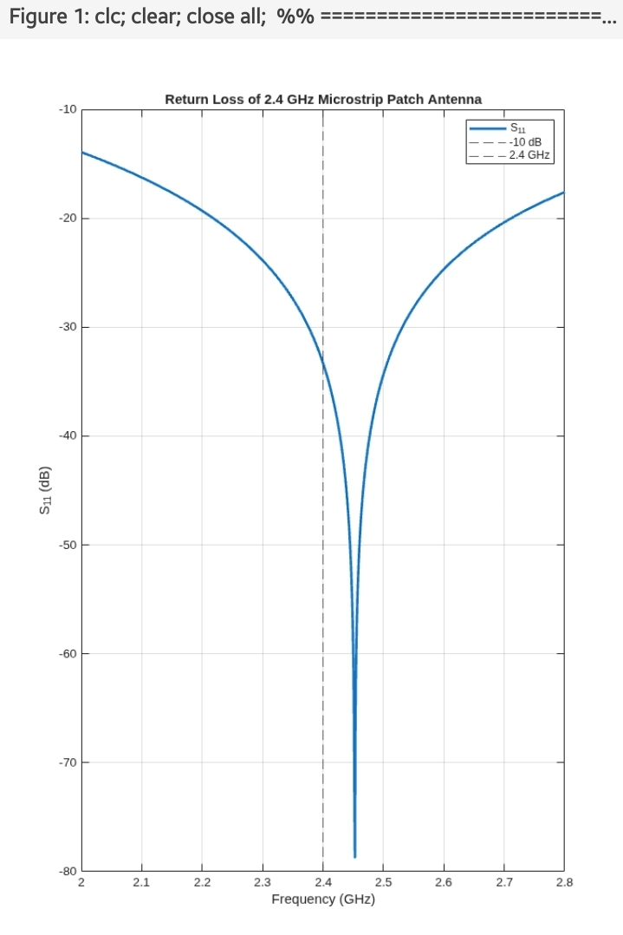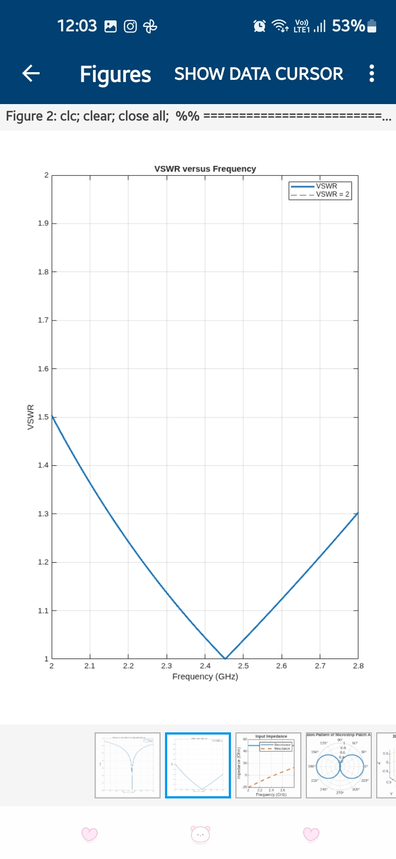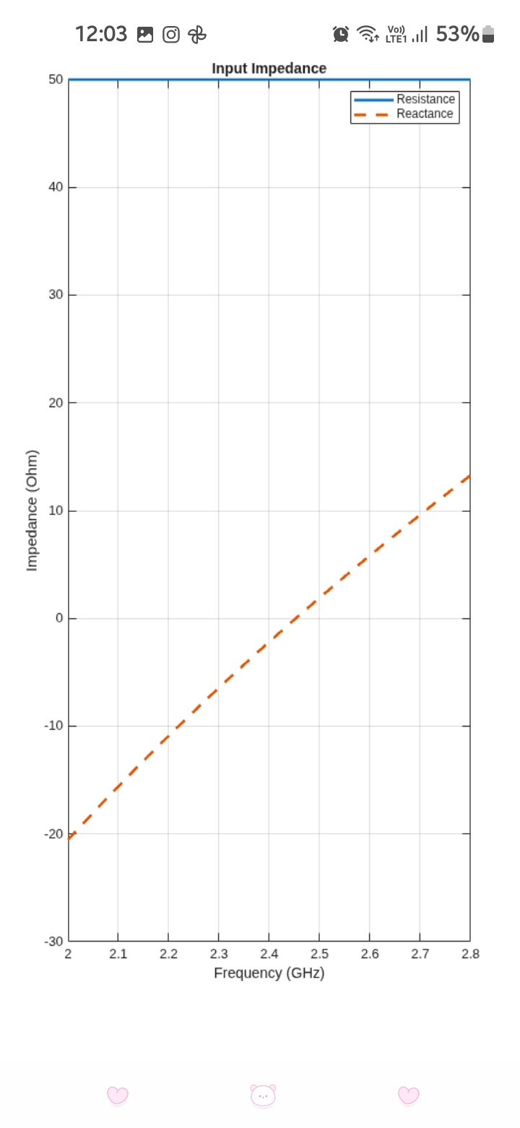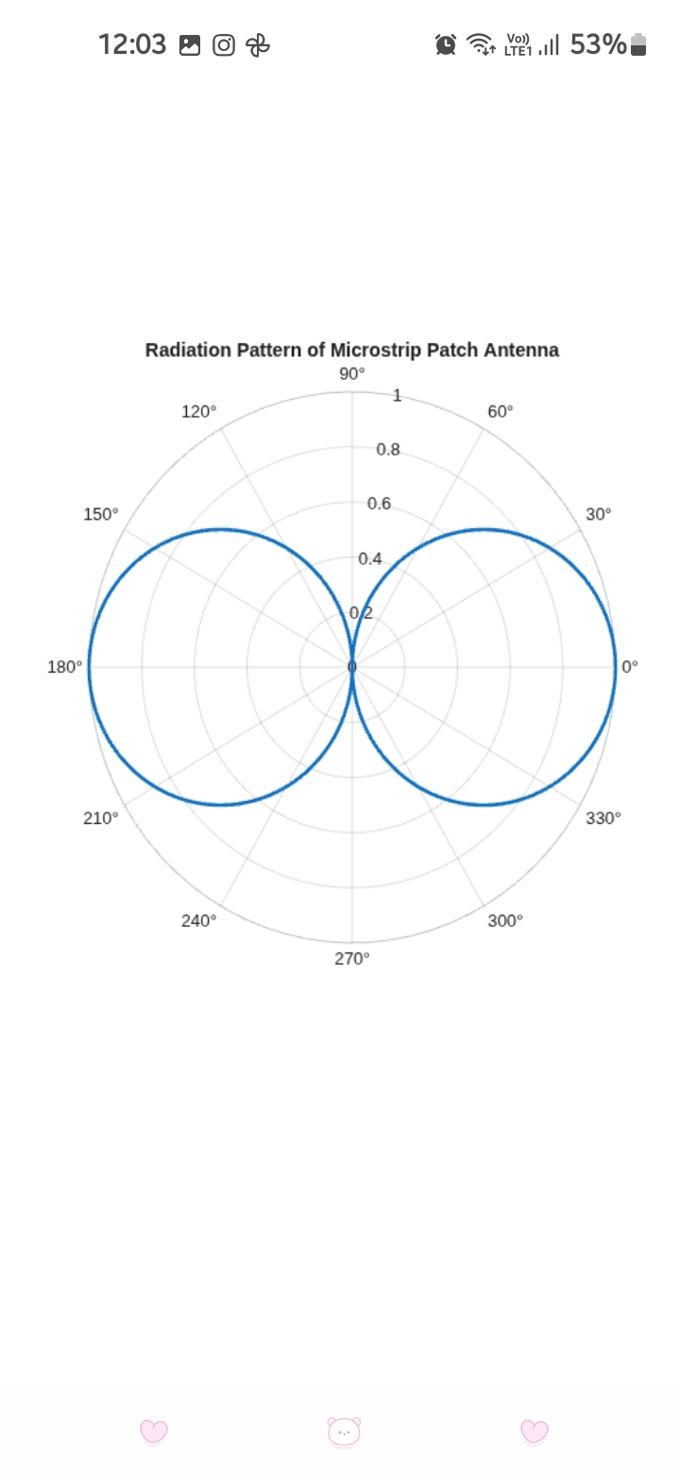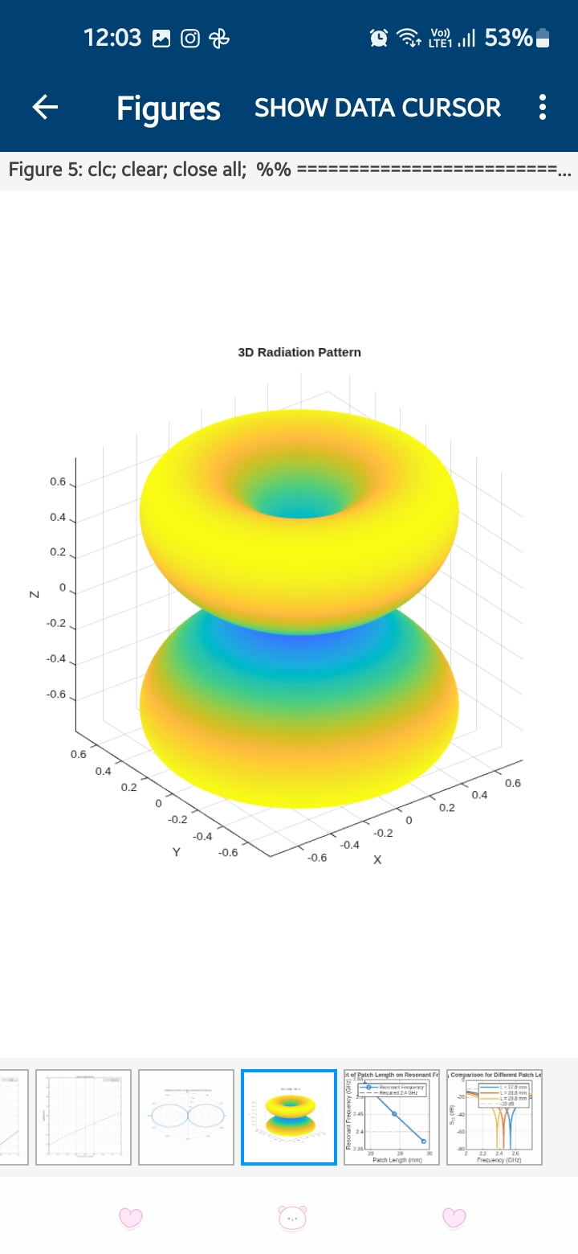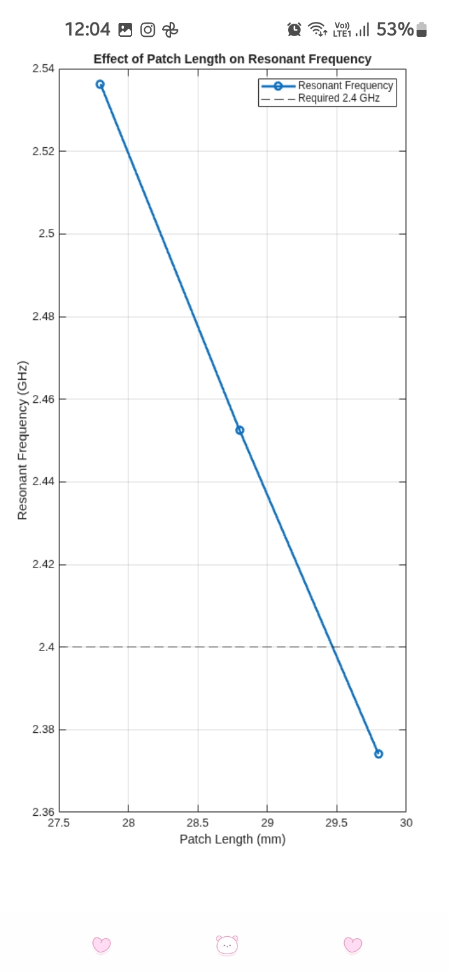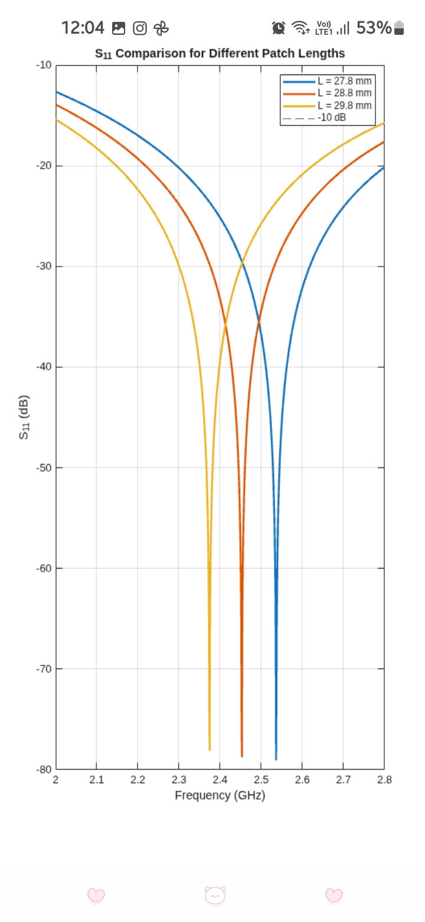

Reflection
The simulation helped me understand how the dimensions and substrate properties of a microstrip patch antenna affect its resonant frequency and impedance matching. The S₁₁ and VSWR responses were used to identify the resonant frequency and matching condition. By changing the patch length from 27.8 mm to 29.8 mm, the effect of physical dimensions on resonance was observed. The radiation-pattern simulation also helped me understand the directional and broadside radiation characteristics of the patch antenna.

Result
A rectangular microstrip patch antenna for 2.4 GHz was successfully designed using an FR-4 substrate with \(\epsilon_r=4.4\) and \(h=1.6\) mm. The S₁₁, VSWR, input impedance, radiation pattern and antenna performance characteristics were obtained. The three patch lengths 27.8 mm, 28.8 mm and 29.8 mm were compared, and the dimension producing the resonant frequency closest to 2.4 GHz with acceptable S₁₁ and VSWR was identified as the optimized design.

